2024 Karmanos Cancer Institute Strategic Research Initiative Grant Program

The Karmanos Cancer Institute is pleased to announce its 2024 competition for Strategic Research Initiative Grants. Applications are being solicited for innovative, high impact proposals, which exhibit great potential of leading to peer-reviewed extramural funding.

This year, funding is available to support outstanding projects that are neither presently funded nor pending review. Two types of funding are available:

- Pre-R01 Type - Projects with the goal of securing R01 level funding. A total budget up to $50,000 each is available in this category. Awards will be made for a period of 12 months after which projects are expected to be submitted for conventional extramural funding. Funds are contingent upon IRB approval of each project, where appropriate.

- Proposal can be single (1) investigator.
- Proposal can have multiple PIs
- Both new research projects and ongoing research projects requiring additional data to be competitive for extramural funding are encouraged.
- Applicants may consider this mechanism as a transition pathway from R21-type to R01-type.
- Proposals may include a recent summary statement from an unfunded extramural attempt.

- Multi-Project Type – Projects with the goal of securing P01, SPORE or other multi-investigator level funding. A 24-month (2 year) budget of $150,000 each is available in this category ($75,000 per year). Awards will be made for a period of 24 months with the second year of funding contingent upon adequate progress in year one. Funds are contingent upon IRB approval of each project, where appropriate.

- Proposals must include a min. of two (2) investigators and max. of four (4) investigators.
- Collaboration across the basic, clinical/translational, and population sciences is encouraged.
- Proposals must include two (2) projects - Applications should include a description of how the
work in each project informs the research of the other projects.

Guidelines for all applications:

- Applications must be cancer-relevant.

- This competition is open only to members of the Barbara Ann Karmanos Cancer Institute. Membership applications are encouraged.

- Applications must describe how the proposed research will address the needs of the KCI catchment area. Projects are expected to engage in research that reduces the cancer burden of the catchment area, addresses key populations within the community, or otherwise supports the community outreach mission of the Cancer Center. Applicants are encouraged to consult with the Associate Center Director for Community Outreach and Engagement, Dr. Hayley Thompson, while developing their proposal.

Please submit all proposals in PDF format – one file per applicant – through the WSU Cayuse SP system by 5PM on the deadline date of February 23, 2024.

If there are any questions, please contact Jayne Bissonette at 313-576-9714 or bissonej@karmanos.org
Detailed application instructions follow.

I. FORMATTING THE APPLICATION

a. PHS 398 forms
The submitted biosketch, budget and continuation pages should be on PHS 398 (Revised 3/2020) forms and be easily readable as the reviewers are reading many applications. No other PHS 398 forms are required.

b. Page length
Pre-R01 Type - Applications are limited to three (3) pages, excluding face page, relevance to catchment area (see Section II.b), budget/budget justification, references, and biographical sketches (PI only). Please use single-spaced text throughout the application.

Multi-Project Type - Applications are limited to six (6) pages (3 per project), excluding face page, relevance to catchment area (see Section II.b), extramural multi-investigator grant rationale (see Section II.c.), budget/budget justification, references, and biographical sketches (PI and co-PI only). Please use single-spaced text throughout the application.

c. Formatting, Font Size, and Margins
All formatting should conform to the NIH Attachment Formatting guidelines:

https://grants.nih.gov/grants/how-to-apply-application-guide/format-and-write/format-attachments.htm

II. PREPARING THE APPLICATION

a. Face Page
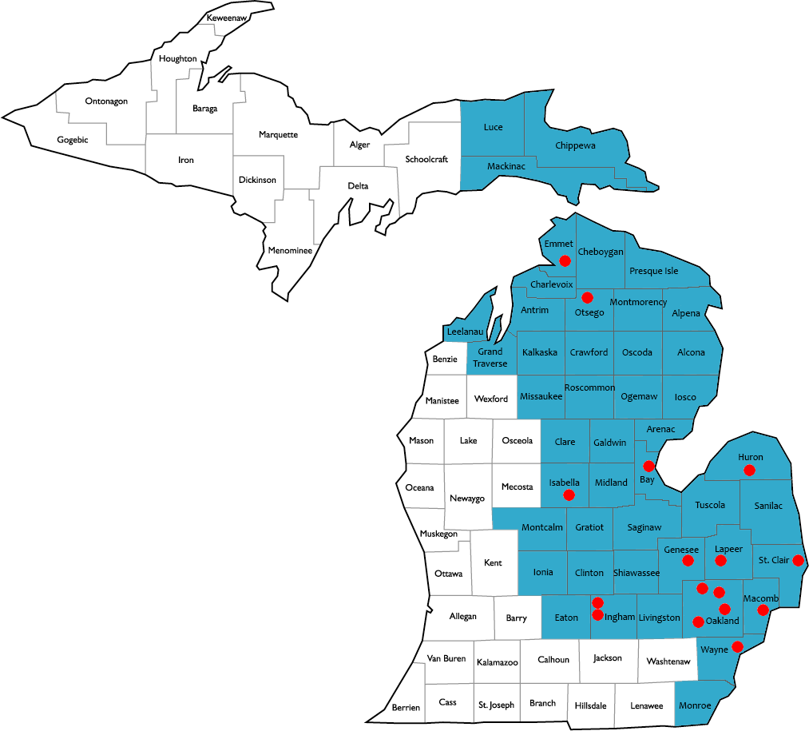
Complete the appropriate form at the end of this solicitation and attach to the front of the application.

b. Relevance to Catchment Area (1/2 page)
Briefly describe how your project would address specific cancer needs of our catchment area (46 of 83 counties of Michigan – see image). This is a vital component of our NCI CCSG, demonstrating how the research performed at KCI impacts the cancer burden and disparities of our catchment area. For additional information on specific cancer burdens and cancer disparities in the catchment area that your work may impact, please contact Hayley Thompson, PhD (hayley.thompson@wayne.edu), Associate Center Director for Community Outreach and Engagement or Brittany Dowe (doweb@karmanos.org), Director, Office of Cancer Health Equity & Community Engagement (OCHECE)

c. For Multi-Project Type Only: Extramural Multi-Investigator Grant Rationale, Integration of Projects, and Timeline (1/2 page)
Briefly describe how the proposal will lead to an extramural multi-investigator (i.e. P01, SPORE) grant application. Describe how the work in each project informs the other project. The results from one project must influence/synergize with work done in the other projects. Finally, provide a realistic timeline for this endeavor including an anticipated submission date of the multi-investigator application.

d. Description of Research Proposed
Pre-R01 Type - Three (3) single-spaced pages, including proposal and figures.
Multi-Project Type - Six (6) single-spaced pages, including proposal and figures. (3 pages per project)

The requested information should be organized under the headings of (i) Specific Aims, (ii) Background, Approach and Preliminary Data (if available) and (iii) References. Please note that References do not count towards the page limit. The proposed experiments should represent a realistic set of goals for the project period. The ability of the principal investigator to clearly define and explain an appropriately focused set of specific aims is an important part of the review process. The rationale for critical experiments to obtain preliminary data should be described as well as the procedures necessary to accomplish the stated goals or aims. Any anticipated difficulties and/or essential controls should be outlined. Please note:

- You are strongly encouraged to discuss the proposed project with a member of the Biostatistics and Bioinformatics Core (https://www.karmanos.org/karmanos/biostatistics-and-bioinformatics-core).
- If the proposed project builds on past internal funding (SRIGs, Program Funds, etc.), the inclusion of outcomes (publications, grant submissions) from this work should be detailed.

e. Budget/Budget Justification
Using the PHS 398 budget form pages, provide details on the proposed budget and justifications for the project period. If you are requesting funding for personnel, include the individual’s name, title, and percent effort. One additional page for budget justification may be included.

Budget allowances:

- Indirect costs are not allowed.
- Salary support for Principal Investigator(s) is not allowed.
- Cancer Center Shared Resource (Core) services should be budgeted according to the usual user fee schedule and must include sign off from the respective Core Director.
- Requests for equipment are discouraged and will be considered only in exceptional circumstances.

f. Biographical Sketches
Using the PHS 398 biographical sketch form pages, provide biosketches for all participating investigators. New biosketch format (effective January 25, 2022) is encouraged (https://grants.nih.gov/grants/forms/biosketch.htm).

III. DELIVERABLES AND EXPECTATIONS

Progress Report: A 1-2 page progress report is required 9 months from the funding start date. For multi-project type awards, the second year funding is contingent upon reasonable progress having been made.

Research Program Presentation: A formal presentation regarding the project and outcomes to be given at a monthly Program meeting (TBM, MI, MT, or PSDR). To be scheduled approximately 12 months after start date.

Publications: All publications must acknowledge funding from the Karmanos Cancer Institute SRIG and relevant agencies providing support.

IV. REVIEW CRITERIA

Review of proposals to be facilitated by KCI Research Administration and will include members of the KCI Scientific Leadership Council and ad hoc reviewers (including external reviewers outside WSU) as appropriate. Considerations for review include (but not limited to):

- Potential to lead to a funded large proposal/program project or similar award
- Are the overall strategy, methodology, and analyses well-reasoned and appropriate to accomplish the specific aims of the project?
- Is the proposed project feasible over the timeline?
- Is the proposed project pertinent and/or includes Karmanos Cancer institute catchment area?
- Does the project utilize KCI Shared Resources?
- For multi-project type proposals: Inclusion of multiple disciplines and/or KCI scientific programs (TBM, MI, MT, PSDR)

V. SUBMITTING THE APPLICATION

All proposals must be submitted in PDF format – one file per applicant – through the WSU Cayuse SP system by 5PM on the deadline date of February 23, 2024. Please adhere to the SPA deadline policy, i.e., finalize proposals no later than 5 days prior to deadline for SPA review.

The sponsor is ”Karmanos Cancer Institute – KCI”. Be sure to enter “2024 SRIG” into the Program Title field.

https://wayne.cayuse424.com/
Login to Cayuse requires a WSU Access ID and Academica password. To submit your internal funding proposal, please follow the steps in the Cayuse user guide (https://research.wayne.edu/spa/ pdf/cayuse_sp_user_guide_2_0_2.pdf). If you have questions about entering and uploading your internal funding proposal, please contact Jayne Bissonette at bissonej@karmanos.org or 313-576-9714.

VI. QUESTIONS

Please direct questions about this funding opportunity to Jayne Bissonette, Grants Development Coordinator at 313-576-9714 or bissonej@karmanos.org. Alternatively, you may contact Valerie Wade, Director Grants Administration at 313-576-4404 or wadev@karmanos.org.

Face Page – 2024 SRIG

TYPE OF SUBMISSION (select one):

[ ] Pre-R01 Type

[ ] Multi-Project Type

TITLE OF PROPOSAL:

_______________________________________________________________  PRINCIPAL INVESTIGATOR  ACADEMIC TITLE DEPARTMENT  TELEPHONE E-MAIL ADDRESS  I AM A MEMBER OF THE FOLLOWING CANCER CENTER PROGRAM:  TUMOR BIOLOGY AND MICROENVIRONMENT  MOLECULAR THERAPEUTICS  MOLECULAR IMAGING  POPULATION STUDIES AND DISPARITIES RESEARCH | ____________________________________________________________________  CO- INVESTIGATOR (if applicable)  ACADEMIC TITLE DEPARTMENT  TELEPHONE E-MAIL ADDRESS  I AM A MEMBER OF THE FOLLOWING CANCER CENTER PROGRAM:  TUMOR BIOLOGY AND MICROENVIRONMENT  MOLECULAR THERAPEUTICS  MOLECULAR IMAGING  POPULATION STUDIES AND DISPARITIES RESEARCH

_______________________________________________________________  CO- INVESTIGATOR (if applicable)  ACADEMIC TITLE DEPARTMENT  TELEPHONE E-MAIL ADDRESS  I AM A MEMBER OF THE FOLLOWING CANCER CENTER PROGRAM:  TUMOR BIOLOGY AND MICROENVIRONMENT  MOLECULAR THERAPEUTICS  MOLECULAR IMAGING  POPULATION STUDIES AND DISPARITIES RESEARCH | ____________________________________________________________________  CO- INVESTIGATOR (if applicable)  ACADEMIC TITLE DEPARTMENT  TELEPHONE E-MAIL ADDRESS  I AM A MEMBER OF THE FOLLOWING CANCER CENTER PROGRAM:  TUMOR BIOLOGY AND MICROENVIRONMENT  MOLECULAR THERAPEUTICS  MOLECULAR IMAGING  POPULATION STUDIES AND DISPARITIES RESEARCH

Face Page, continued

ANIMALS? YES NO DATE OF APPROVAL:

HUMAN SUBJECTS? YES NO DATE OF APPROVAL:

TOTAL PROPOSED BUDGET: $

OTHER KEY PERSONNEL (including CANCER CENTER PROGRAMS/WSU DEPARTMENTS):

SITE(S) OF PROPOSED PROJECT:

CANCER CENTER SHARED RESOURCES (CORES) TO BE USED IN PROPOSED PROJECT (MUST INCLUDE CORE DIRECTOR SIGN-OFF):

CORE NAME: _______________________ CORE DIRECTOR SIGNATURE: _______________________
CORE NAME: _______________________ CORE DIRECTOR SIGNATURE: _______________________
CORE NAME: _______________________ CORE DIRECTOR SIGNATURE: _______________________
CORE NAME: _______________________ CORE DIRECTOR SIGNATURE: _______________________
CORE NAME: _______________________ CORE DIRECTOR SIGNATURE: _______________________

Face Page, continued

CONDITIONS OF AWARD

I HEREBY APPLY TO THE KARMANOS CANCER INSTITUTE STRATEGIC RESEARCH INITIATIVE GRANT (SRIG) INTERNAL RESEARCH FUND PROGRAM. BY MY SIGNATURE BELOW, I ASSUME RESPONSIBILITY FOR THE PROPOSED WORK AND AGREE TO THE FOLLOWING CONDITIONS IN THE EVENT THAT AN AWARD IS MADE:

AS A CANCER CENTER MEMBER, I AGREE TO ACKNOWLEDGE MY KARMANOS CANCER INSTITUTE AFFILIATION, IN ADDITION TO MY DEPARTMENTAL AFFILIATION, ON ALL PUBLICATIONS AND PRESENTATIONS RESULTING FROM THIS WORK.

THE KCI SRIG MECHANISM IS FUNDED, IN PART, BY THE CANCER CENTER SUPPORT GRANT NIH P30 CA22453. I AGREE TO ACKNOWLEDGE THIS GRANT IN ANY PUBLICATIONS RESULTING FROM THIS WORK. FURTHER, THE PUBLICATION MUST BE SUBMITTED TO PUBMEDCENTRAL DATABASE, FOLLOWING THE NIH PUBLIC ACCESS POLICY.

I UNDERSTAND THAT PRELIMINARY DATA OBTAINED THROUGH SRIG GRANTS ARE EXPECTED TO BE THE BASIS FOR EXTRAMURAL GRANT AND CONTRACT APPLICATIONS. I UNDERSTAND THAT I AM EXPECTED TO SUBMIT AN APPLICATION WITHIN 12 MONTHS FOLLOWING AWARD AND WILL UTILIZE THE GRANT DEVELOPMENT CAUCUS MECHANISM OR AN INTERNAL MOCK STUDY SECTTION REVIEW PRIOR TO SUBMISSION.

I UNDERSTAND THAT I MUST SUBMIT IACUC and/or IRB APPROVAL DOCUMENTS TO KCI RESEARCH ADMINISTRATION PRIOR TO BEGINNING ANY ANIMAL/HUMAN RELATED RESEARCH.

I AGREE TO PROVIDE MY CANCER CENTER PROGRAM LEADER WITH THE OPPORTUNITY TO REVIEW THE CONSEQUENT GRANT APPLICATION PRIOR TO ITS SUBMISSION.

I AGREE TO PROVIDE PROGRESS REPORTS AS REQUIRED BY KCI RESEARCH ADMINSTRATION.

SIGNATURES/APPROVALS

_______________________________________________________________________________________________________________________________________
PRINCIPAL INVESTIGATOR DATE

_______________________________________________________________________________________________________________________________________
PRINCIPAL INVESTIGATOR (required only for Multi-Project type, leader of second project) DATE

